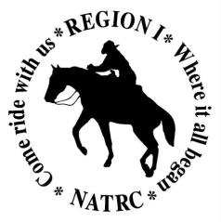
NATRC Region 1 Convention Registration
Saturday March 21, 2026
Lutheran Church of the Resurrection Community Room
6365 Douglas Blvd, Granite Bay, CA 95746
Please Print Legibly
Name___________________________________________Phone________________
Address______________________________________________________________
City____________________________________________State_____Zip__________
Email Address ________________________________________________________________
Include a phone number/email so registration confirmation can be sent. If multiple people are registering on one form, write names and contact info on back of this form.
NATRC member Yes______ No_______
Registration : Enter Number attending: Fees:
Adults- (_____) X $35/each $_____________
Juniors (____) X $15 each $_____________
***********************************************************
LUNCHES:
Junior lunches are FREE**- indicate # ________
# of adult lunches (____) X $15 per lunch $_____________
(lunches must be ordered by March 19)
If paying via Pay Pal, add $2.00 per registrant $_____________
Total Due $_____________
Make checks payable to: NATRC Region 1. Pay Pal also accepted but please include the additional fee and make sure to label your Pay Pal payment as “2026 NATRC Convention”. Pay Pal email address is: natrcr1@gmail.com
Mail checks to: NATRC Region 1
C/0 Linda Thomason,
5033 Southside Ranch Rd, Rocklin, CA 95677
Registration fee includes coffee, tea, water, breakfast treats, speakers and the afternoon awards presentation. Lunch is purchased separately and will consist of multiple trays with a variety of meats, tuna/egg salad, cheeses, green salad, potato salad, chips, beverage, and deserts. Bon Apetit!

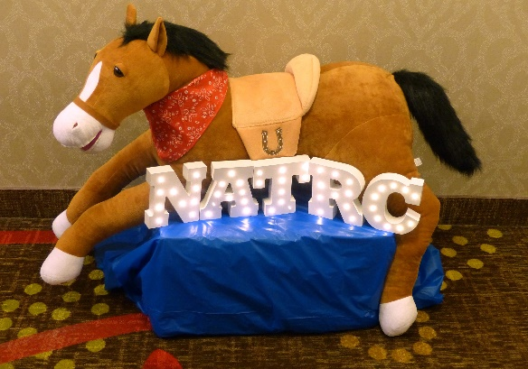
Retain this information page, do not return it with your registration
Please send in registration forms as early as possible as a lunch tally is needed by March 19th. There are picnic tables outside the community room if you choose to bring your own lunch.
Directions:
Take exit 103A from Hwy 80 and merge onto Douglas Blvd for 4.7 miles. Head towards Folsom Lake. The Lutheran Church of the Resurrection will be on your left a couple miles before reaching Folsom Lake. If you reach the lake, you’ve gone too far. Please park in the large back lot so we leave room in the small front parking lot for other church activities.
Silent Auction:
There will be a SILENT AUCTION to benefit Region 1. If you can provide any silent auction items early to Linda Thomason, it would be appreciated. If not, bring them to the event and give them to Stephanie Swain or Linda Thomason. NATRC Region 1 is a tax-exempt organization. Donation forms with our Tax ID number are available from Linda Thomason for qualified items. Please help by soliciting donations from local businesses or by donating new or gently used items-they do NOT have to be horse related items. ** All silent auction funds go towards supporting rides, including the Junior Rider Fund** There is NO raffle, just the silent auction.
Awards Donations:
Personal or Business donations towards the year end awards are very appreciated. You can support a specific award, ribbons for the division of your choice or mark the donation as “no preference”. Make checks out to NATRC Region 1 and mail to Linda Thomason at the above address. Your name will be recognized on the Awards program and a tax exempt donation form is available if needed. Thanks for your support!!
Questions? Contact Linda Thomason or Stephanie Swain, Convention Chairs
510-708-1439 linda.thomason0610@gmail.com
707-529-6330 stephswain@earthlink.net
Convention Schedule: Subject to adjustments if needed
Registration: 8:15-9am (coffee and breakfast goodies available). Pick up your packet at the registration desk.
Membership application forms, and 2026 ride/clinic entry forms will be at the registration table.
9-9:15 am Welcome and introduction
9:15-10:30 am speaker #1
10:30-1045 am break.
1045 a12noon speaker #2
12:00-1:30 lunch break. Check out the silent auction. Speakers will be on site for questions.
1:30-2pm NATRC Region 1 member meeting
2-~3:30 NATRC Region 1 2023 Awards presentation. Silent Auction closes at the end of the Awards program. Please see Linda or Stephanie and pay for your items via check, cash or Pay Pal.
Congratulations to all 2025 award recipients.
Please help clean up the room after the event. With help we can clean up quickly AND HAVE OUR CLEANING DEPOSIT REFUNDED. Thankyou!!

